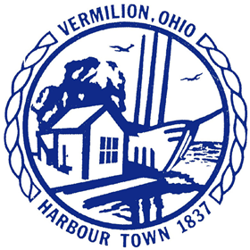
City of Vermilion, Ohio
A Small Town on a Great Lake www.cityofvermilion.com

Vermilion City Council Committee Meetings
Monday, February 10, 2020 @ 7:00 p.m.
Location: Municipal Court Complex, 687 Decatur Street, Vermilion, Ohio
A G E N D A
___________________________________________________________________________________________________________

HEALTH & SAFETY COMMITTEE
Brian Holmes, Chairman; Steve Herron, Vice Chairman; Committee of the Whole
- Fire Chief’s Report Chris Stempowski
- Police Chief’s Report Chris Hartung

UTILITIES COMMITTEE
Frank Loucka, Chairman; Emily Skahen, Vice; Committee of the Whole
- Review of City-Wide Water Meter Replacement Project (Ord. 2020-6) Chris Howard
- Update on Flow Meters Chris Howard

STREETS, BUILDINGS & GROUNDS COMMITTEE
Steve Holovacs, Chairman; Barb Brady, Vice Chairman; Committee of the Whole
- Vermilion Community Pool Plan Terry Parker
- Fulper Lot Mayor Forthofer
- Authorize Administration to go out to bid for Highbridge Road (OPWC Project) Chris Howard

FINANCE COMMITTEE
Barb Brady, Chairman; Frank Loucka, Vice Chairman; Committee of the Whole
- 2020 Budget Overview Amy Hendricks

LEGISLATIVE COMMITTEE
Monica Stark, Chairman; Steve Holovacs, Vice Chairman; Committee of the Whole

